DMI3-G3-MICHAEL OYEKU

Assignment 1 — Your First Agentic Session

Task 1 — Install Claude Code

Screenshot 1 — Terminal showing `claude --version` with the version number visible

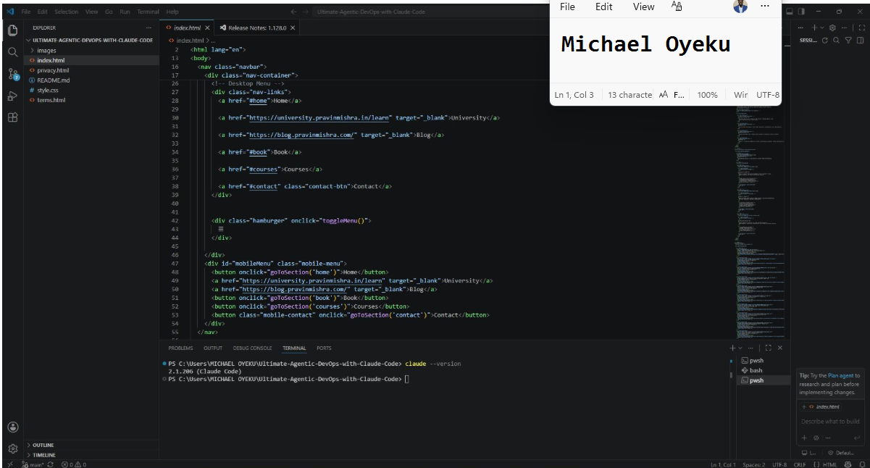

Screenshot 2 — Claude Code authenticated and showing the terminal prompt (your name visible)

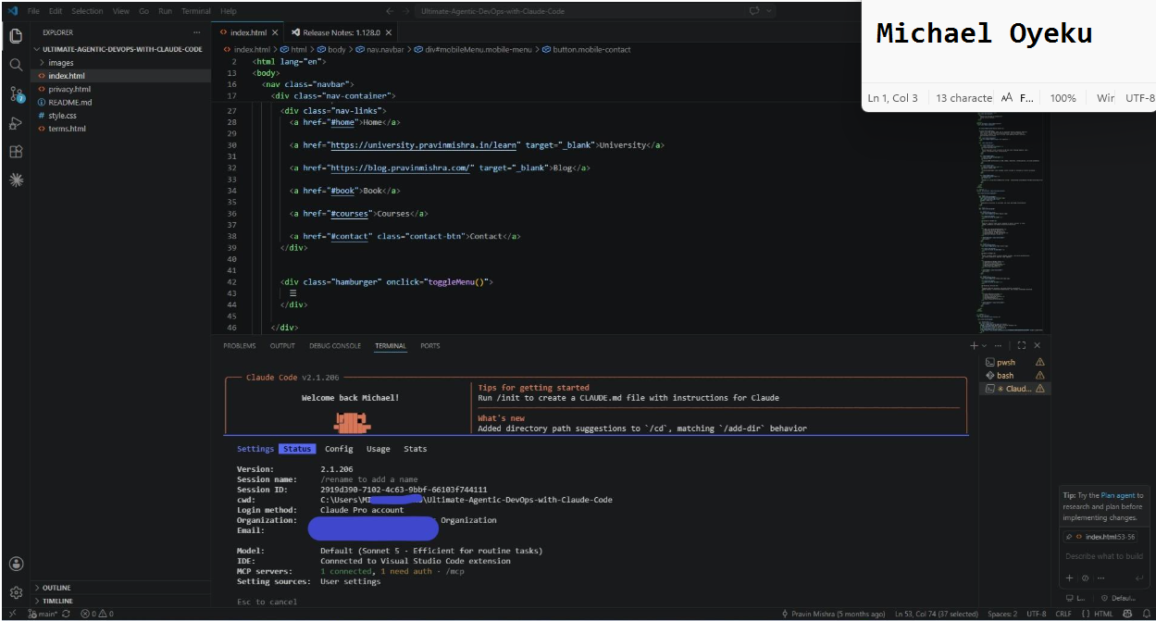

Task 2 — Fork and Clone the Starter Repository

Screenshot 3 — VS Code with the project open, file tree visible showing `index.html`, `style.css`, `images/`

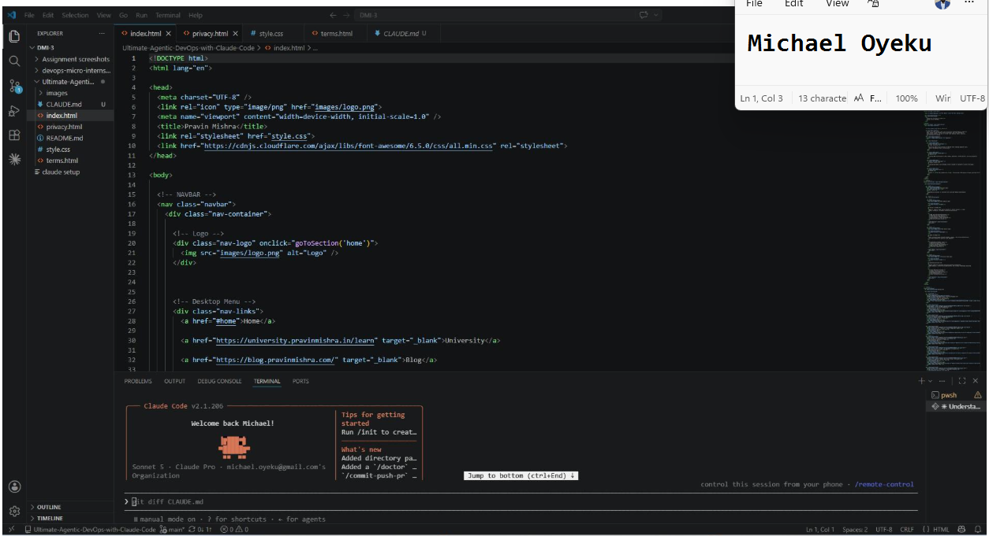

Task 3 — Observe the Agentic Loop
Screenshot 4 — Claude's response to the first question, showing it read the files (tool calls visible)

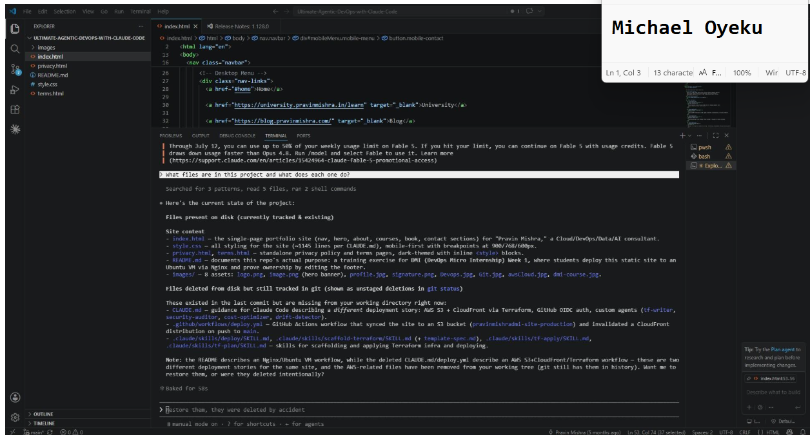

Screenshot 5 — Claude's response to the second question, showing it ran a command and reported the line count

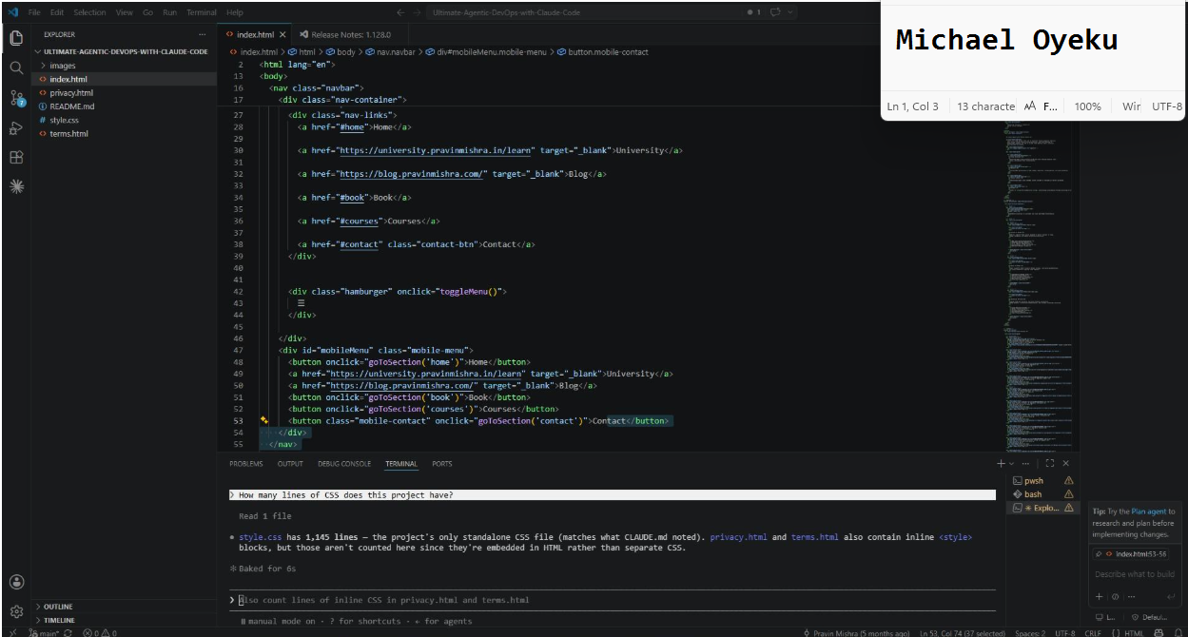
GitHub Repository URL
https://github.com/mykofonics/Ultimate-Agentic-DevOps-with-Claude-Code
Assignment 2 — Teaching Claude Your Project

Task 1 — Capture the Before State

Screenshot 1 — Claude’s generic response before CLAUDE.md exists (project contains only `index.html`, `style.css`, `images/`, `README.MD`, `privacy.html`, `terms.html`)

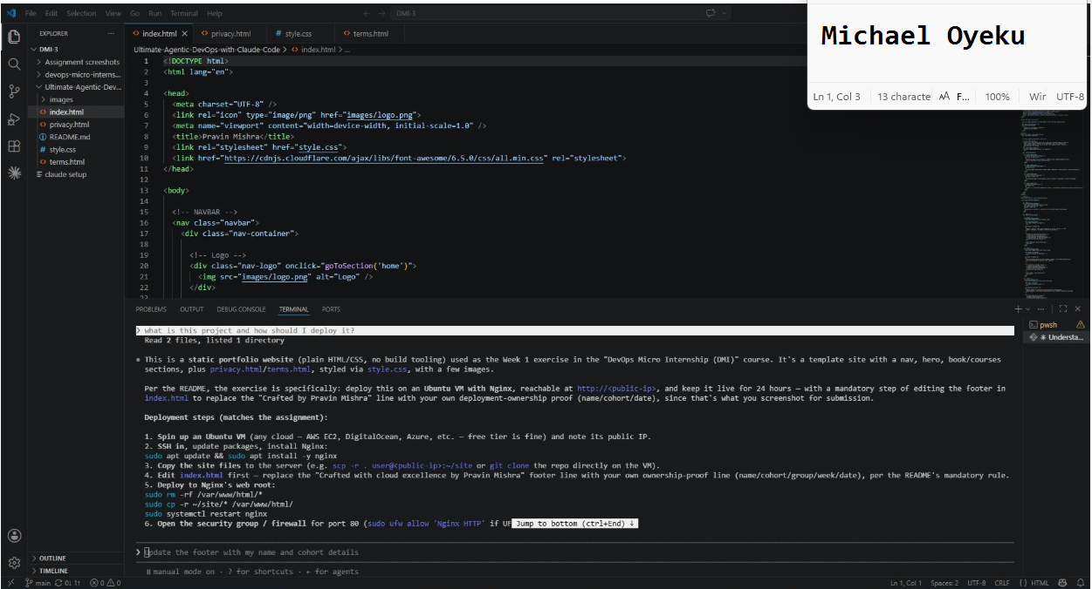
Task 2 — Generate the First Draft with /init
Screenshot 2 — The auto-generated CLAUDE.md open in VS Code showing its content
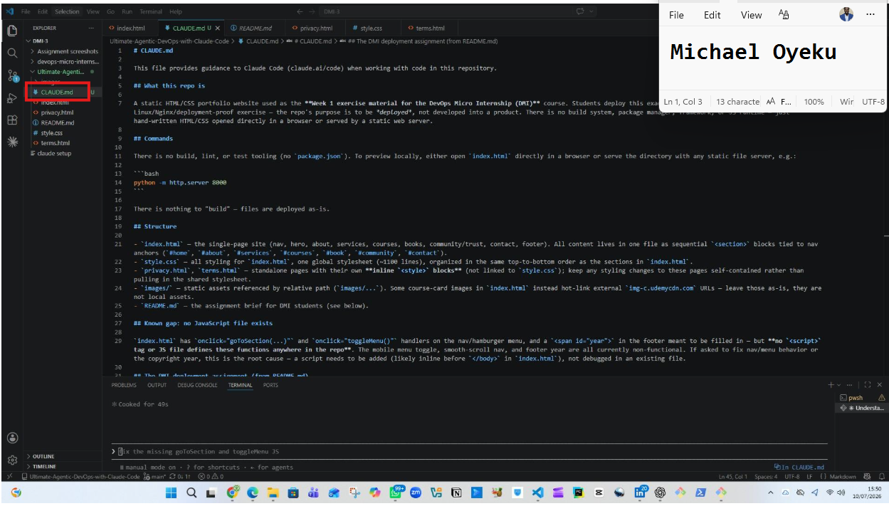
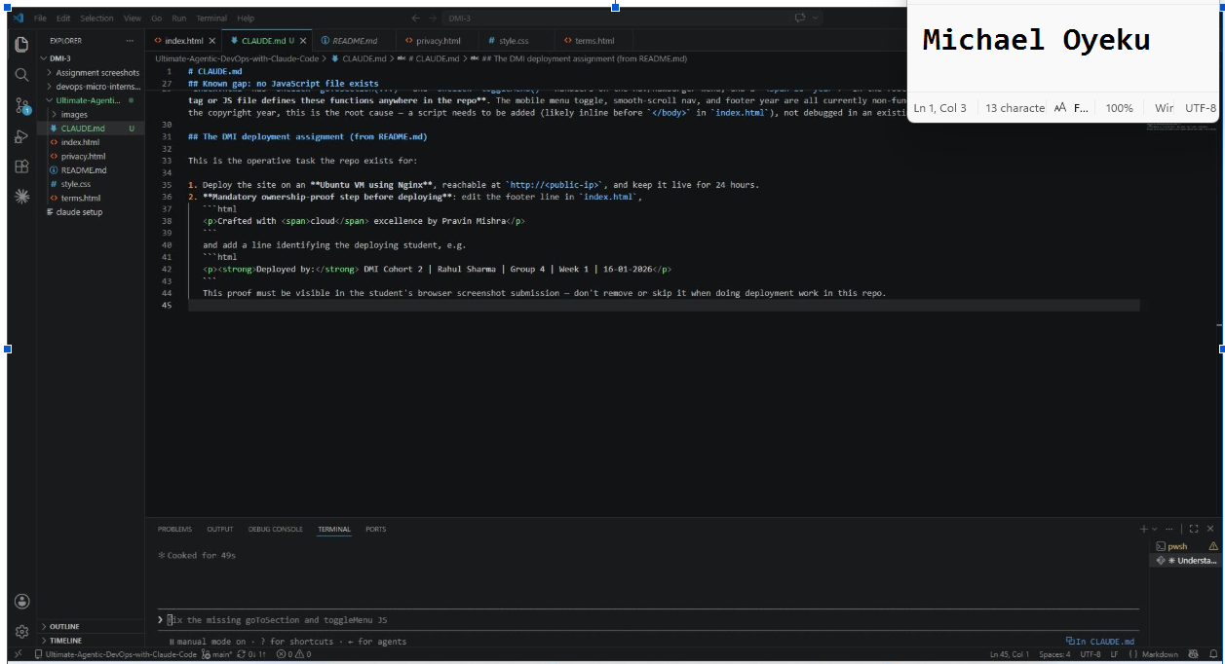
Task 3 — Customize the CLAUDE.md
Screenshot 3 — Your customized CLAUDE.md in VS Code showing all 5 sections (scroll to show the full file)

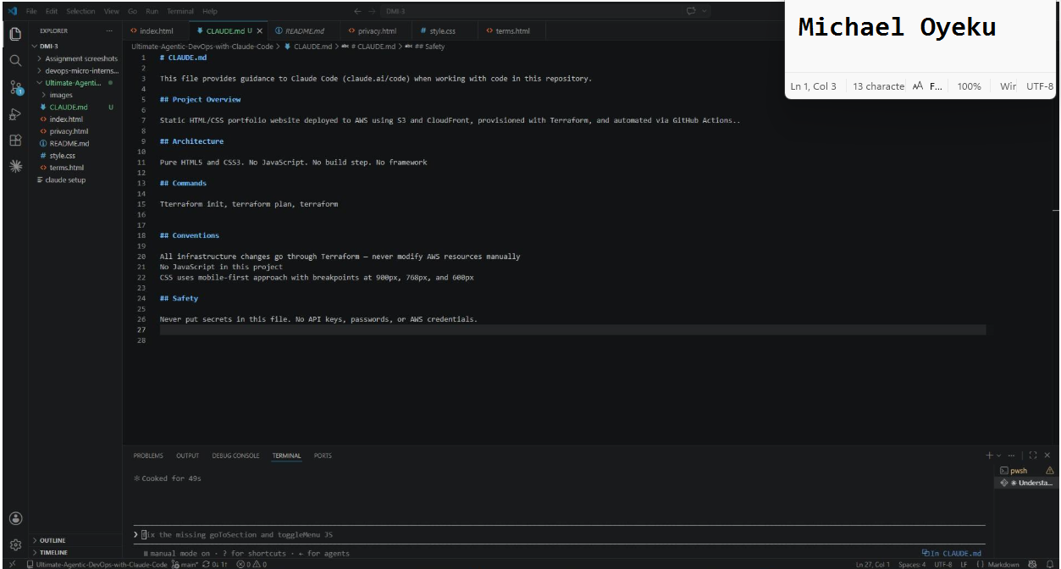
Task 4 — Test the After State
Screenshot 4 — Claude's specific, detailed answer after reading CLAUDE.md (Claude mentioning S3, CloudFront and Terraform)

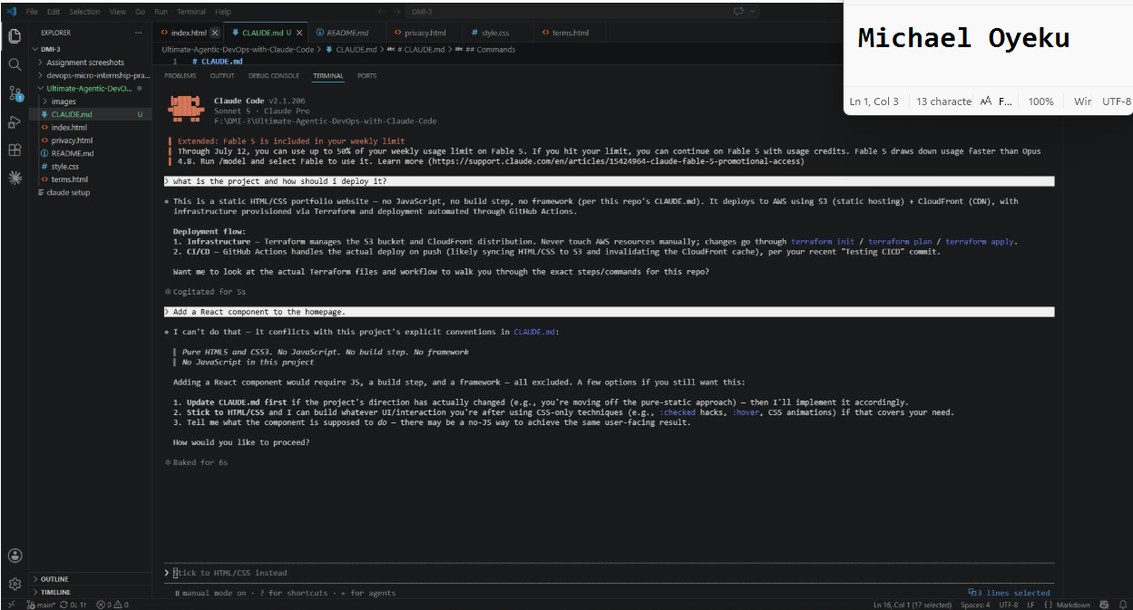

Screenshot 5 — Claude refusing or warning against adding React because of the "No JavaScript" convention defined in CLAUDE.md
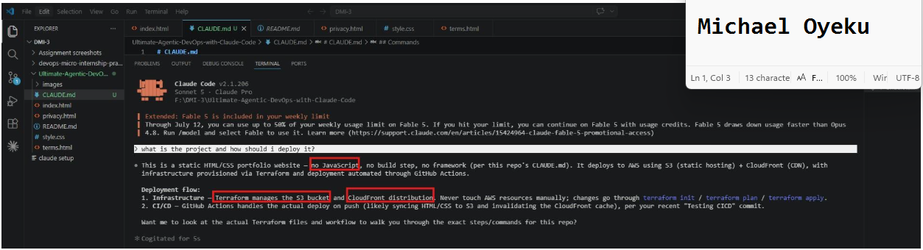
Task 5 — Commit and push your changes to your fork in GitHub
Screenshot 6 — `CLAUDE.md` visible in your GitHub repository after pushing the commit
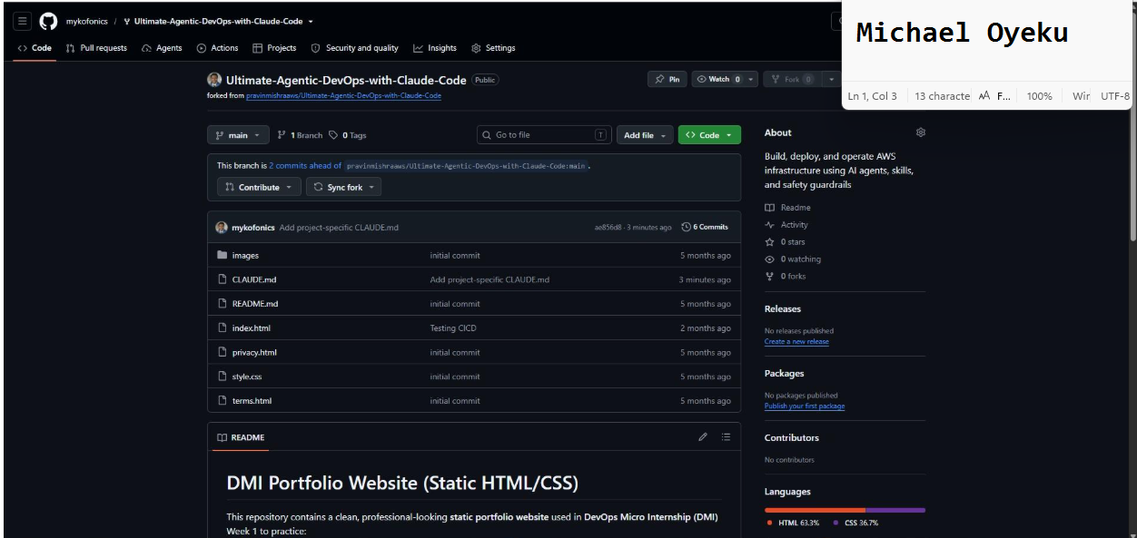
GitHub Repository URL
https://github.com/mykofonics/Ultimate-Agentic-DevOps-with-Claude-Code.git

Assignment 3 — Building Your Command Center
Task 1 — Create the Skill Folder Structure
Screenshot 1 — VS Code sidebar showing `.claude/skills/` folder with all 4 subfolders visible
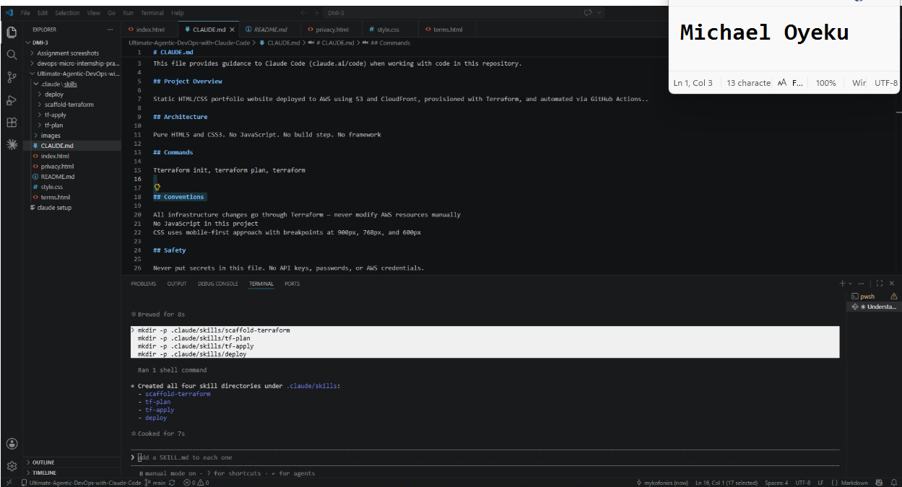
Task 2 — Add the Skill Files
Screenshot 2 — `.claude/skills/scaffold-terraform/` open in VS Code showing both `SKILL.md` and `template-spec.md`

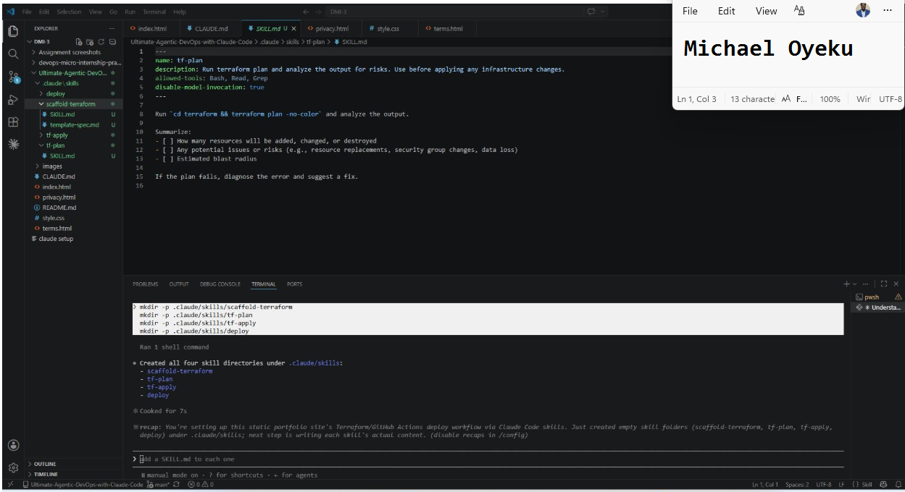
Screenshot 3 — `tf-plan/SKILL.md` frontmatter showing `allowed-tools: Bash, Read, Grep` (no Write) and `disable-model-invocation: true`
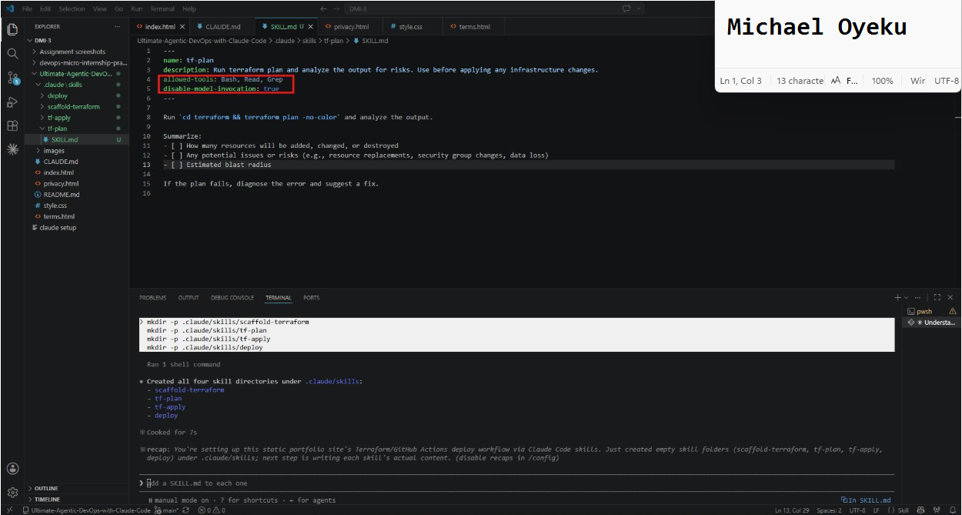
Task 3 — Run /scaffold-terraform
Screenshot 4 — Claude's response showing the scaffold complete with the file list

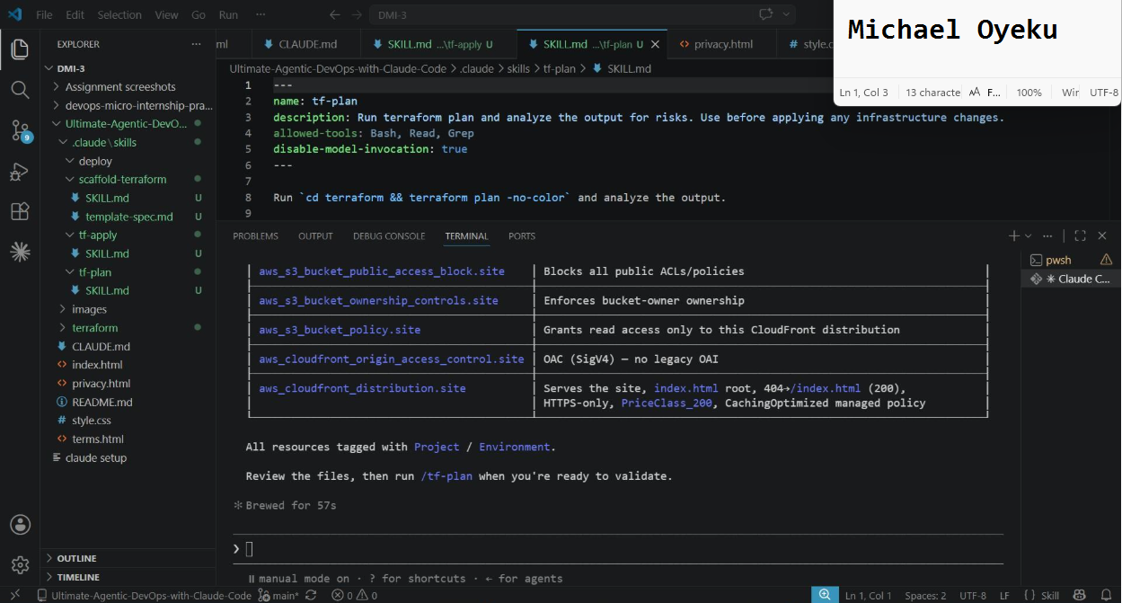
Screenshot 5 — VS Code sidebar showing the `terraform/` folder with all generated files inside
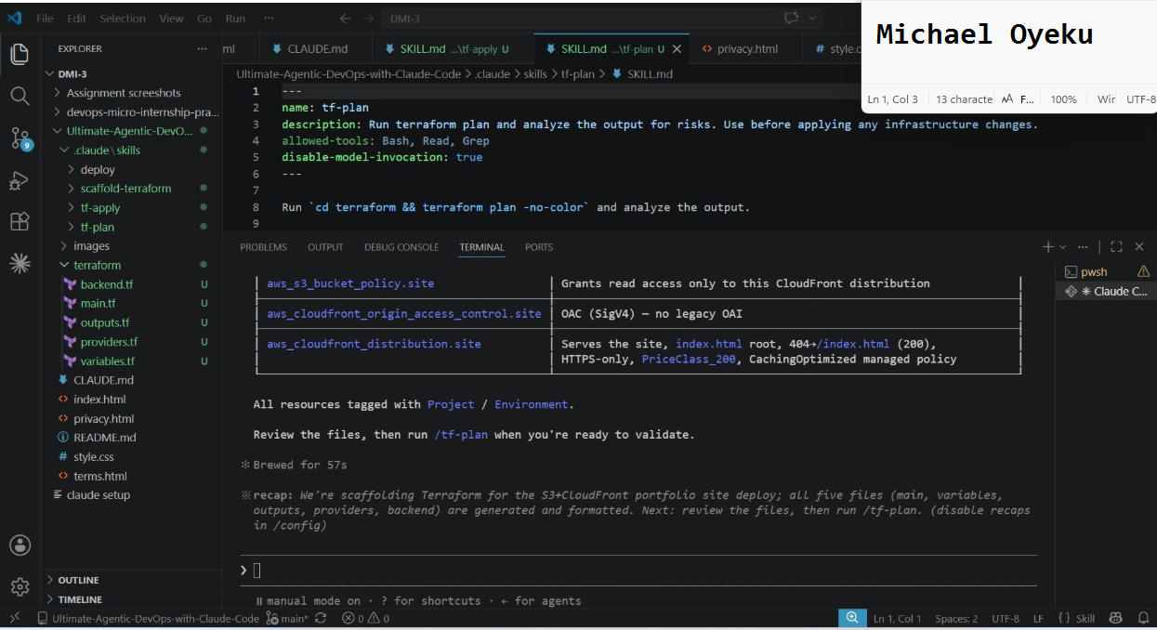
Task 4 — Run terraform init and /tf-plan
Screenshot 6 — Claude's `/tf-plan` response showing it ran the command and analyzed the result (pass or auth error both count)

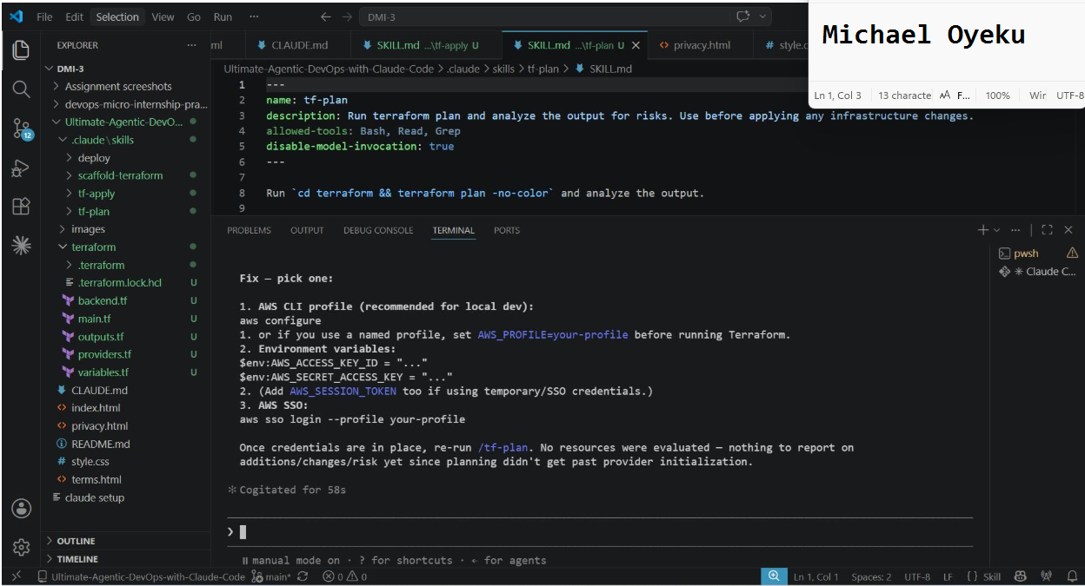
GitHub Repository URL
https://github.com/mykofonics/Ultimate-Agentic-DevOps-with-Claude-Code.git

LinkedIn post URL
https://www.linkedin.com/posts/oyeku-michael-2215a920_dmibypravinmishra-agenticai-claudecode-share-7481438548362072064-BmlK/?utm_source=share&utm_medium=member_desktop&rcm=ACoAAARb4_kBmnrqkDDsuuYPPXrVCKNYnevZPAo

Assignment 4 — Building Your AI Team
Task 1 — Create the Agents Folder and Add Files
Screenshot 1 — VS Code sidebar showing `.claude/agents/` with all 3 files
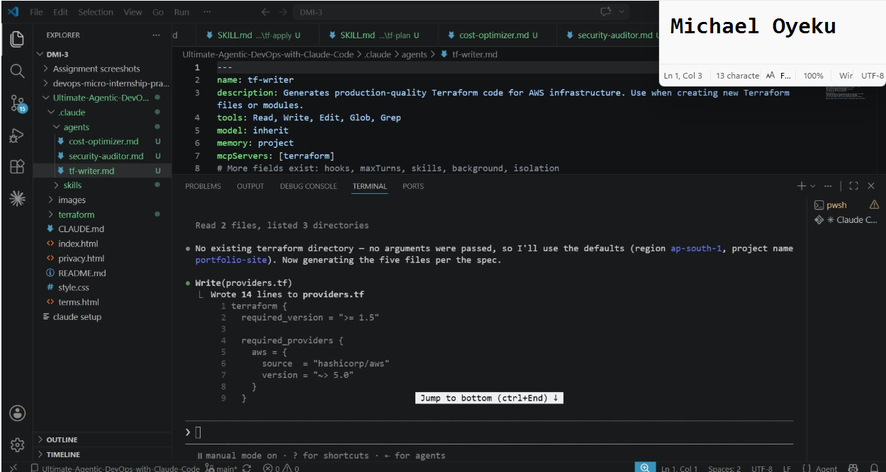
Task 2 — Compare the Agent Configurations
Analyze the configuration differences between the three agents and demonstrate understanding of model and tool selection.
Written Answers
1. Why does the cost optimizer use Haiku instead of Sonnet?

- Cost optimization tasks are simple and rule-based.
- They do not need deep reasoning.
- Haiku is faster and cheaper than Sonnet.
So it saves money on frequent, large scans.

2. Why does the security auditor NOT have Write in its tools list?

- The auditor's job is to find problems, not fix them.
- It should only read and report issues.
- No write access keeps it from changing infrastructure by accident.
This keeps detection separate from repair, as a safety measure.

3. Why does the tf-writer use `inherit` instead of a specific model?

- inherit means the subagent uses the same model as the main session.
- This keeps its ability level matched to the parent session.
- Terraform code needs strong reasoning to get resources and syntax right.
So inherit avoids locking it to a weaker, fixed model.

Screenshot 2 — `security-auditor.md` frontmatter showing model and tools configuration

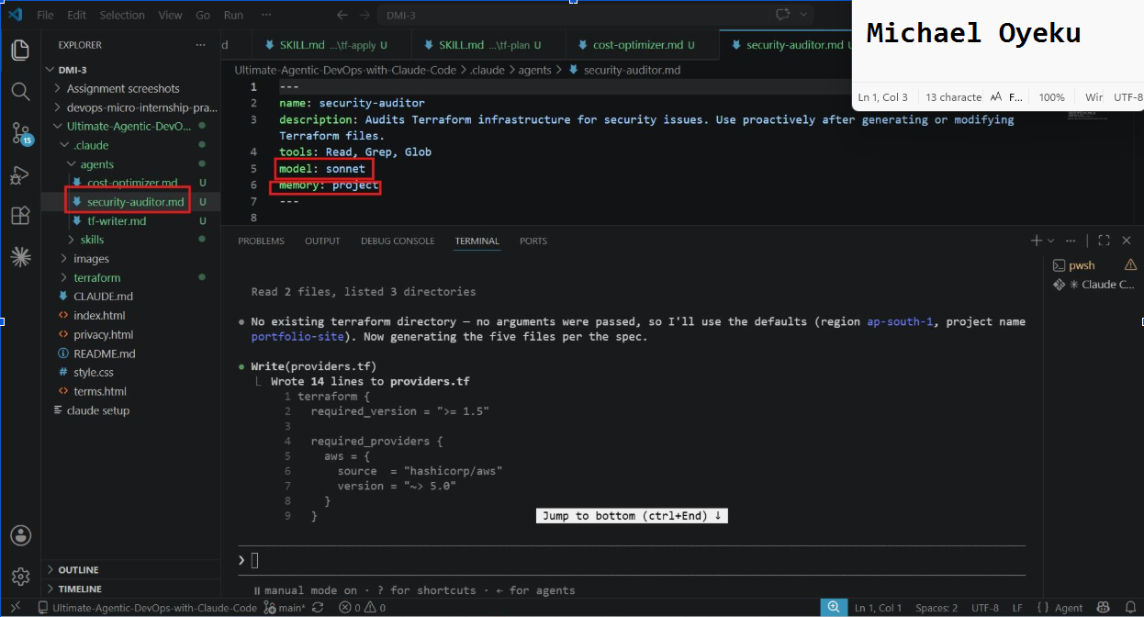
Screenshot 3 — `cost-optimizer.md` frontmatter showing the model and tools configuration
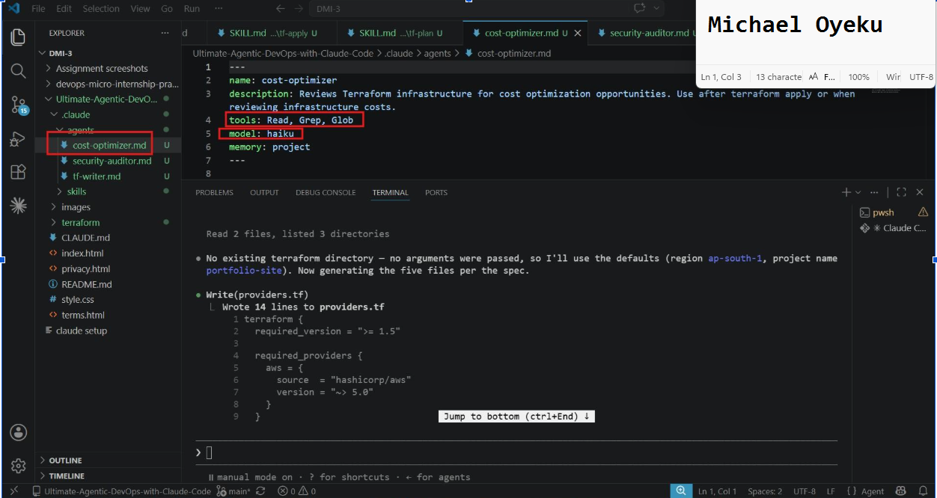
Task 3 — Run the Security Auditor
Screenshot 4 — The delegation message showing Claude launched the security-auditor

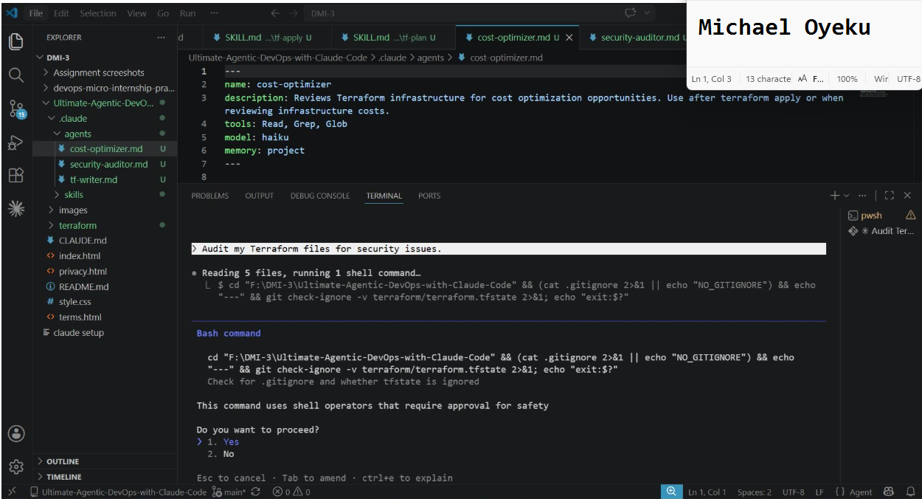
Screenshot 5 — Security audit report output

Task 4 — Run the Cost Optimizer
Screenshot 6 — The full cost optimization report

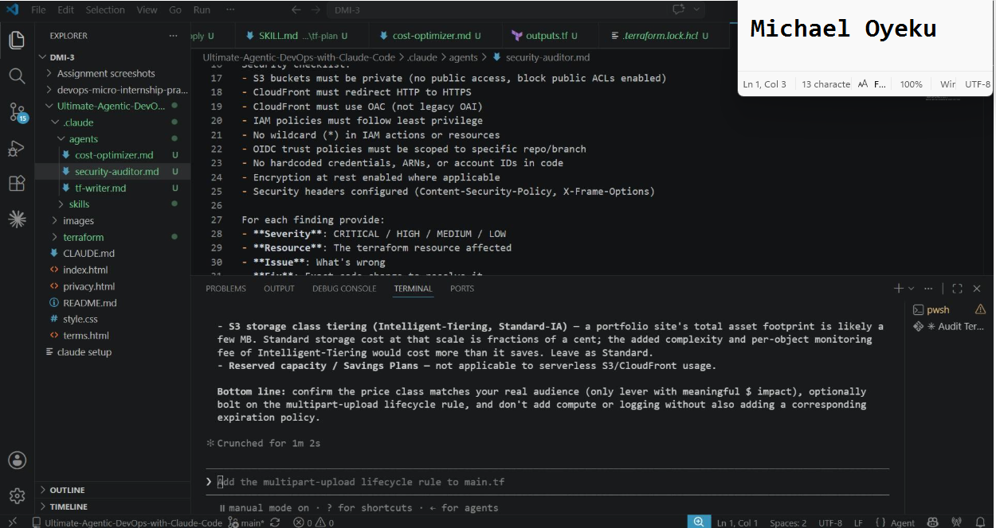
GitHub Repository URL
https://github.com/mykofonics/Ultimate-Agentic-DevOps-with-Claude-Code.git

Assignment 5 — Connecting Claude to the Outside World
Task 1 — Create a GitHub Personal Access Token

Screenshot 1 — GitHub token creation page showing the selected scopes (repo, read:user) — token value must NOT be visible
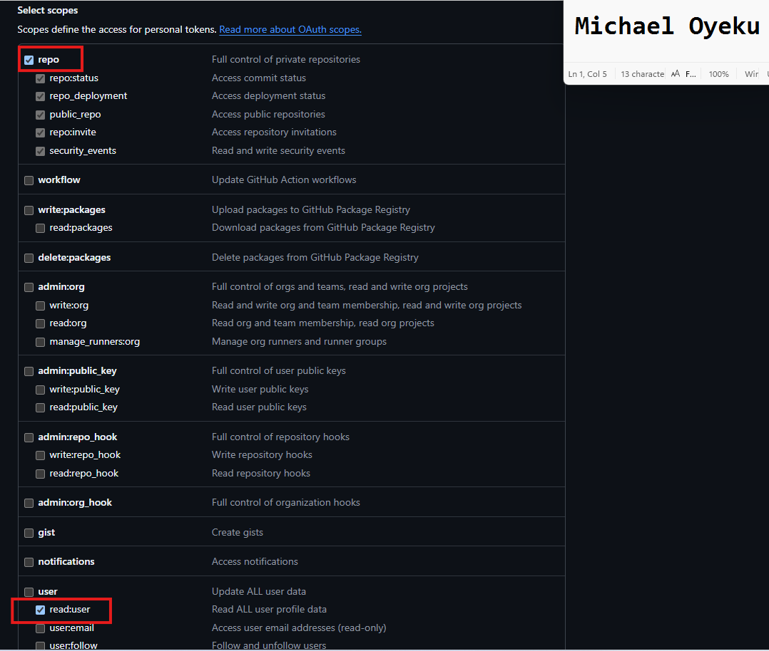

Task 2 — Create .mcp.json at the Project Root

Screenshot 2 — .mcp.json open in VS Code showing the full configuration
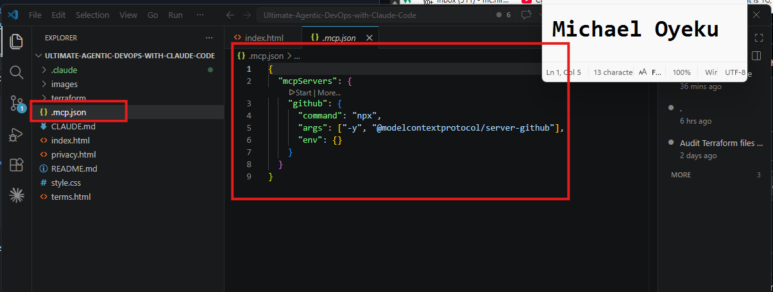

Task 3 — Add Your Token to settings.local.json

Screenshot 3 — settings.local.json open in VS Code showing the env section — blur or cover the actual GitHub token value
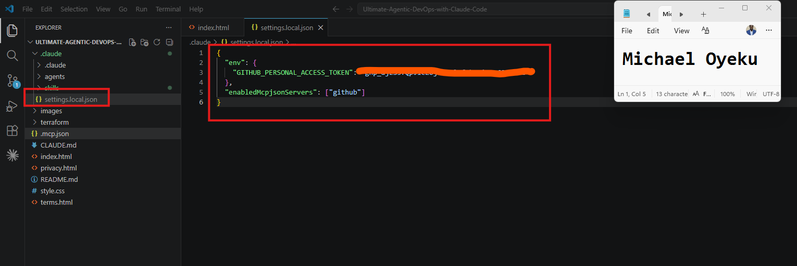

Task 4 — Verify the Connection with /mcp

Screenshot 4 — /mcp output showing github: connected
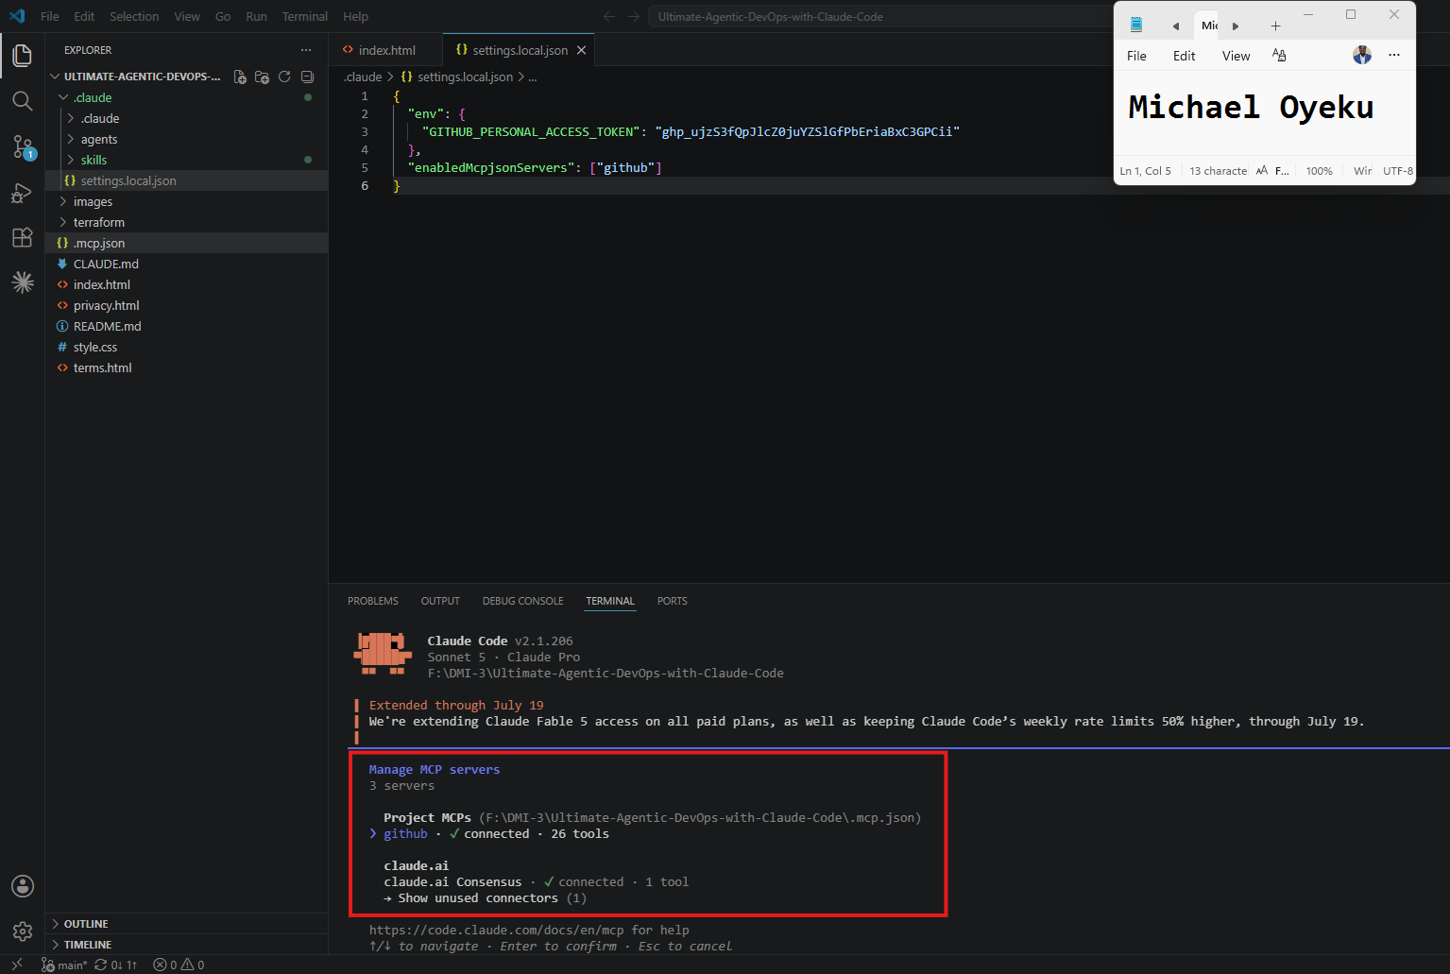

Task 5 — Run a Live GitHub Query

Screenshot 5 — Claude's response showing the GitHub MCP tool call and the retrieved README.md content.
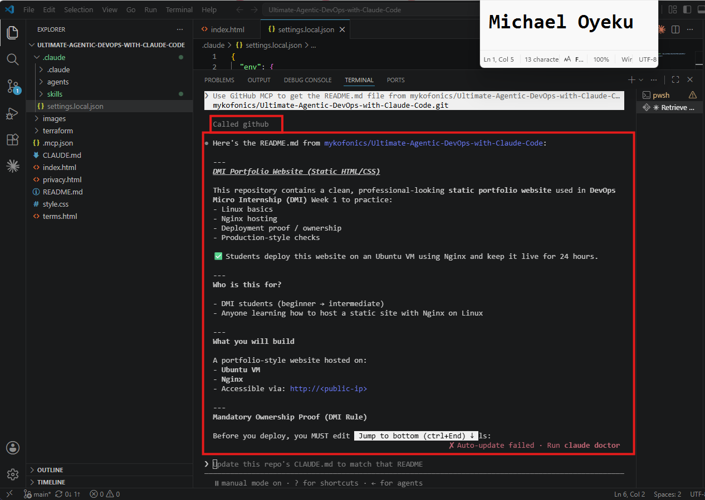

GitHub Repository URL
https://github.com/mykofonics/Ultimate-Agentic-DevOps-with-Claude-Code.git
__________________________

Security Confirmation
Confirm below:
- settings.local.json is added to .gitignore
- GitHub token is NOT exposed in repository or screenshots
Yes, I confirm it.

Assignment 6 — Safety Rails for Your AI Agent
Task 1 — Create Claude Code Configuration Structure
Screenshot 1 — `.claude` folder structure visible in VS Code Explorer

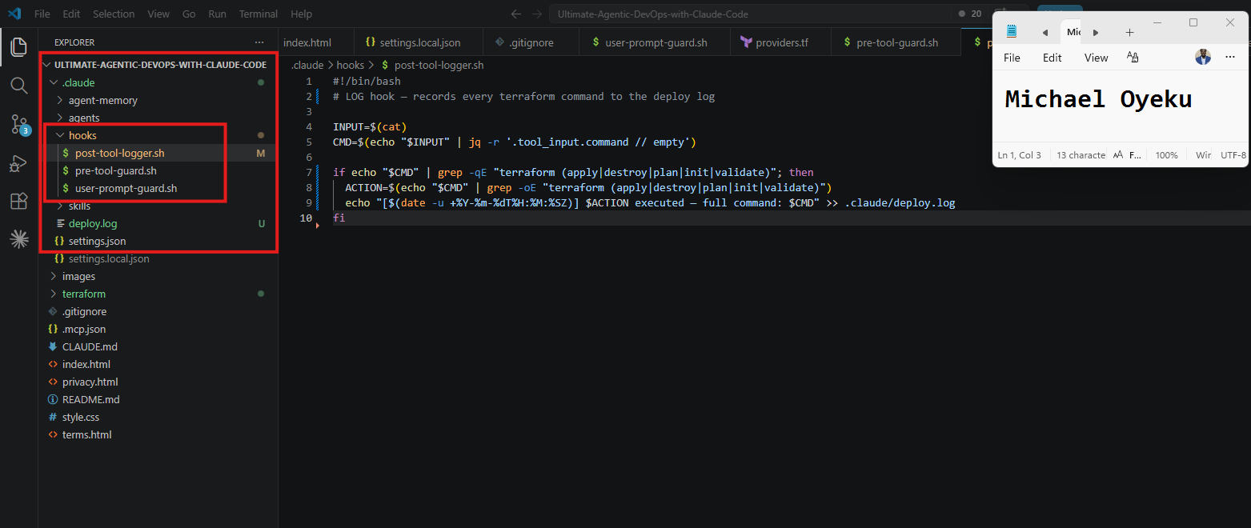
Task 2 — Create the UserPromptSubmit Hook Script
Screenshot 2 — `user-prompt-guard.sh` open in VS Code showing the hook script

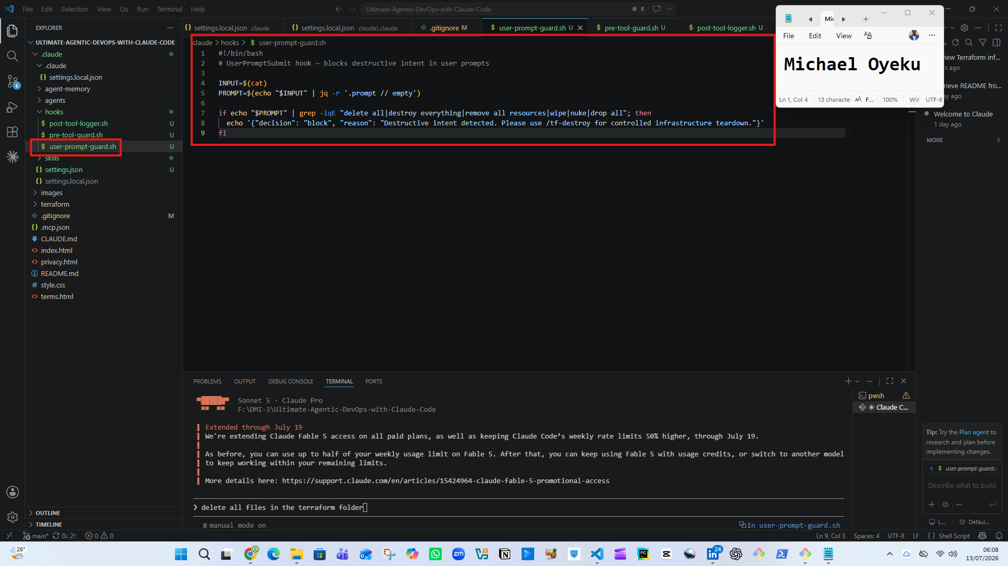
Task 3 — Create the PreToolUse Hook Script
Screenshot 3 — `pre-tool-guard.sh` open in VS Code showing the hook script

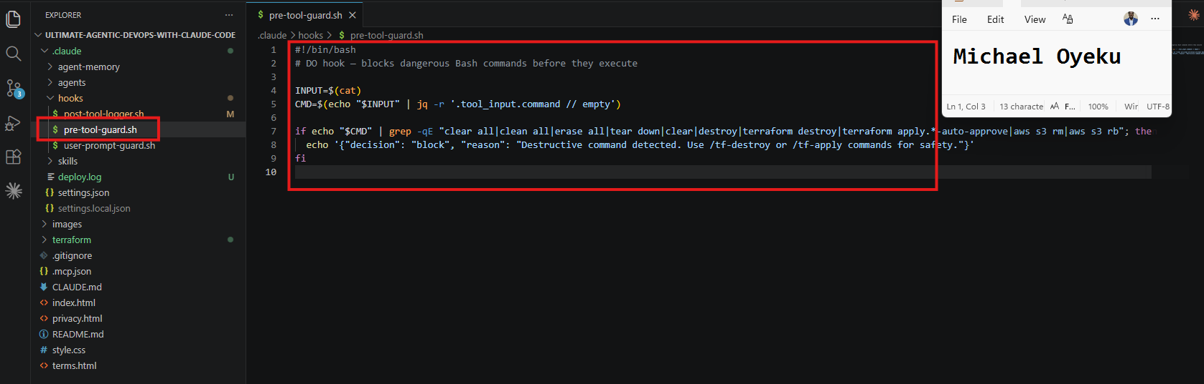
Task 4 — Create the PostToolUse Hook Script
Screenshot 4—`post-tool-logger.sh` open in VS Code showing the hook script

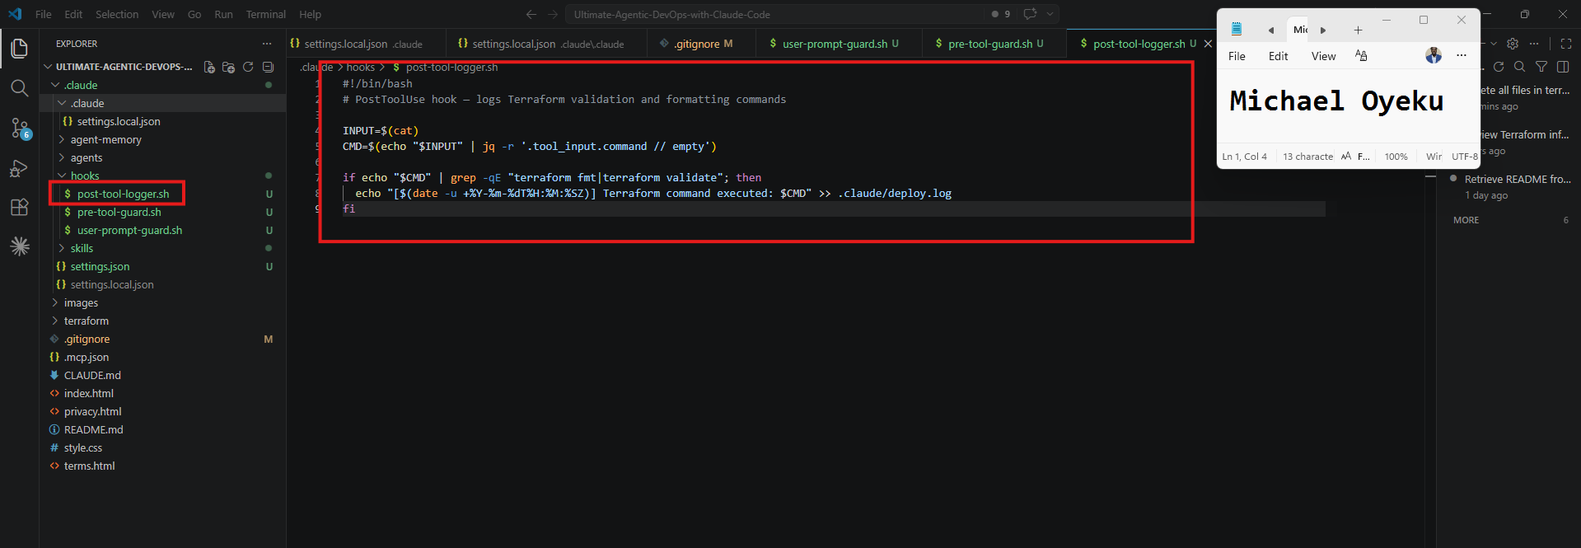
Task 5 — Configure settings.json to Connect Hook Scripts
Screenshot 5 — `settings.json` open in VS Code showing permissions and hooks configuration

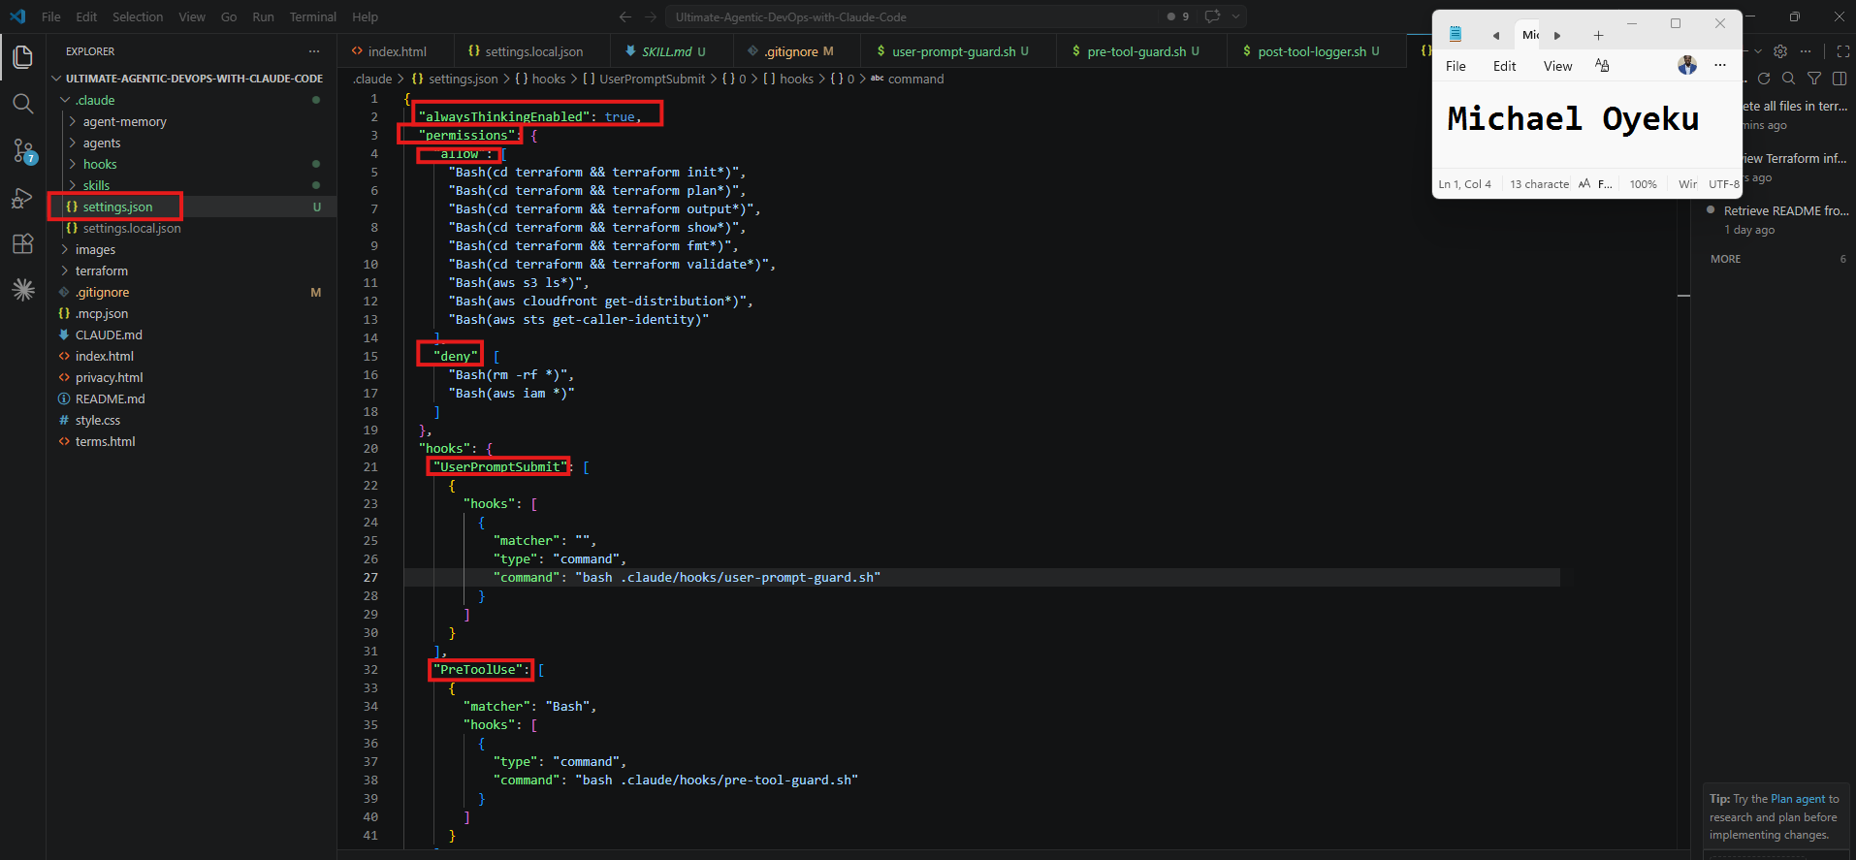

Task 6 — Test the UserPromptSubmit Hook
Screenshot 6 — UserPromptSubmit hook blocking the destructive prompt

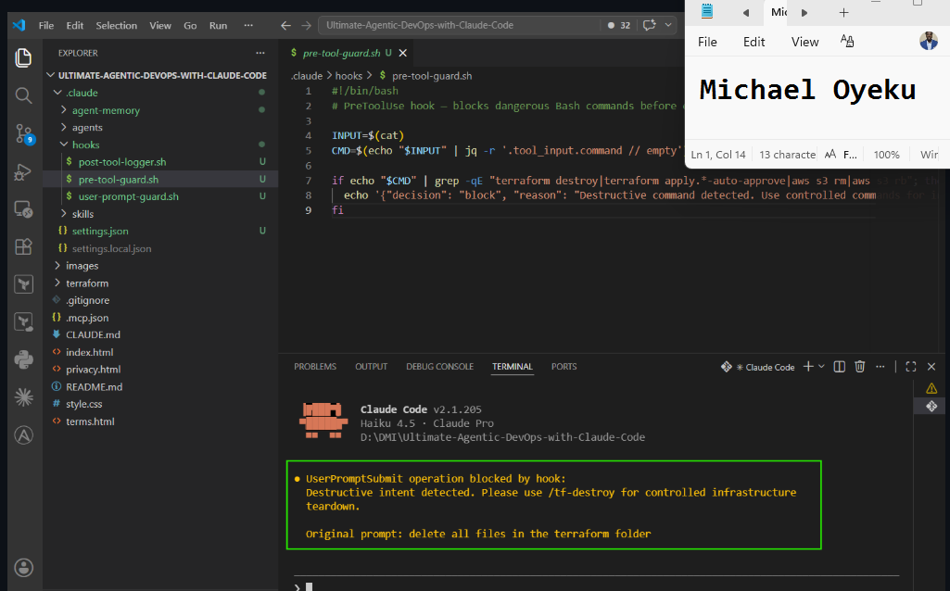
Task 7 — Test the PreToolUse Hook
Screenshot 7 — PreToolUse hook blocking terraform destroy

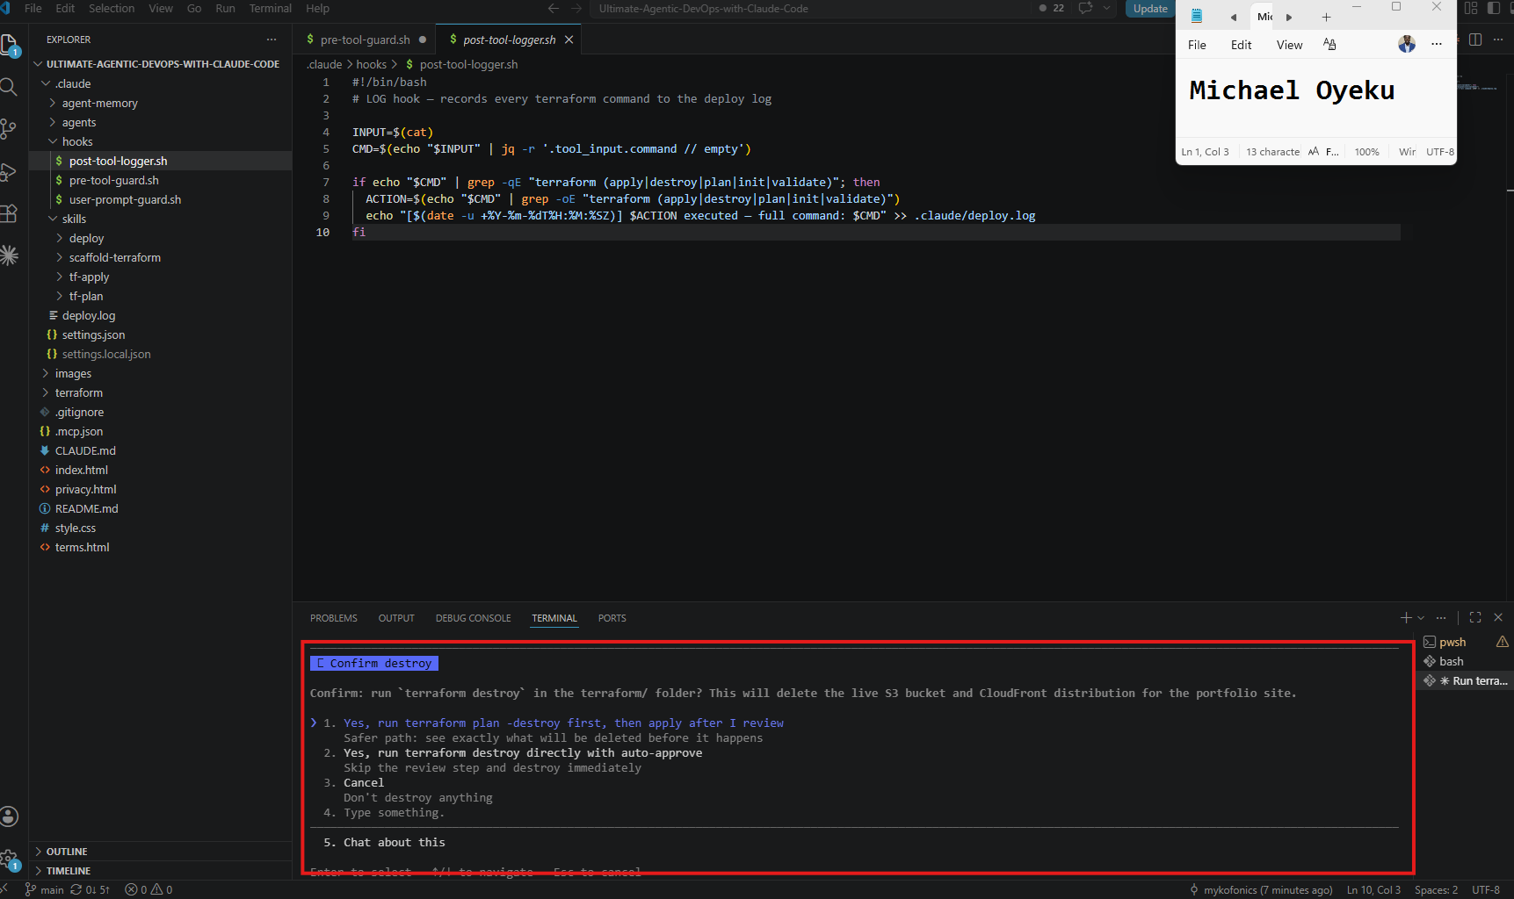
Task 8 — Test the PostToolUse Logging Hook
Screenshot 8 — Claude running terraform validate successfully
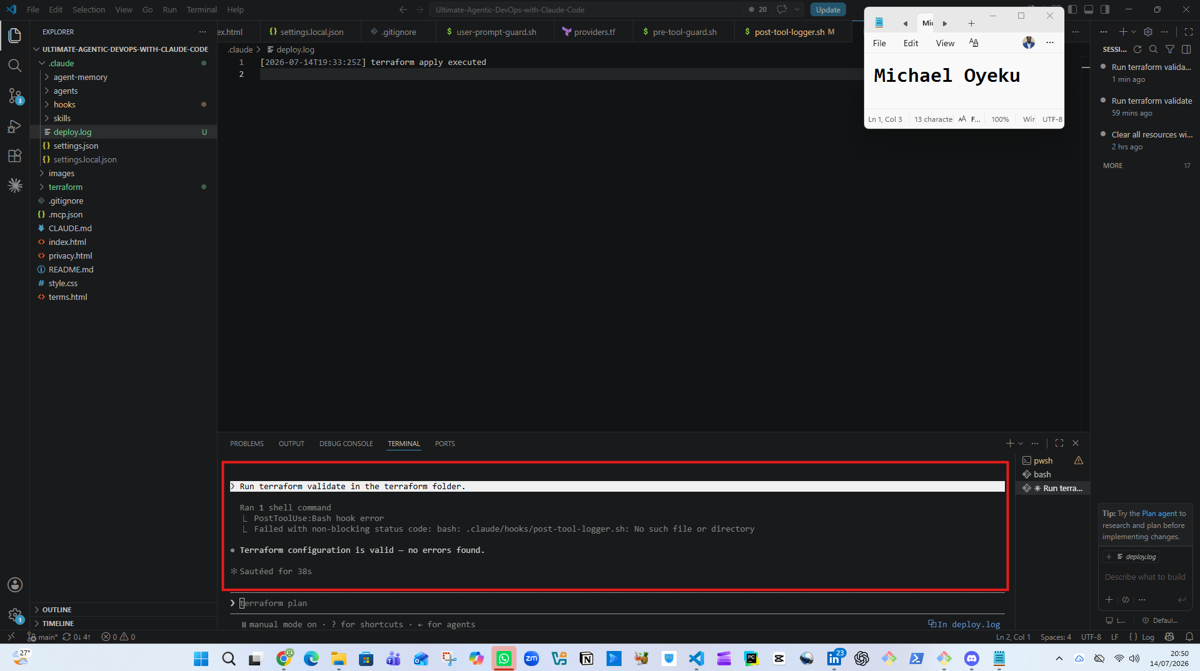
Screenshot 9 — `.claude/deploy.log` showing the logged command

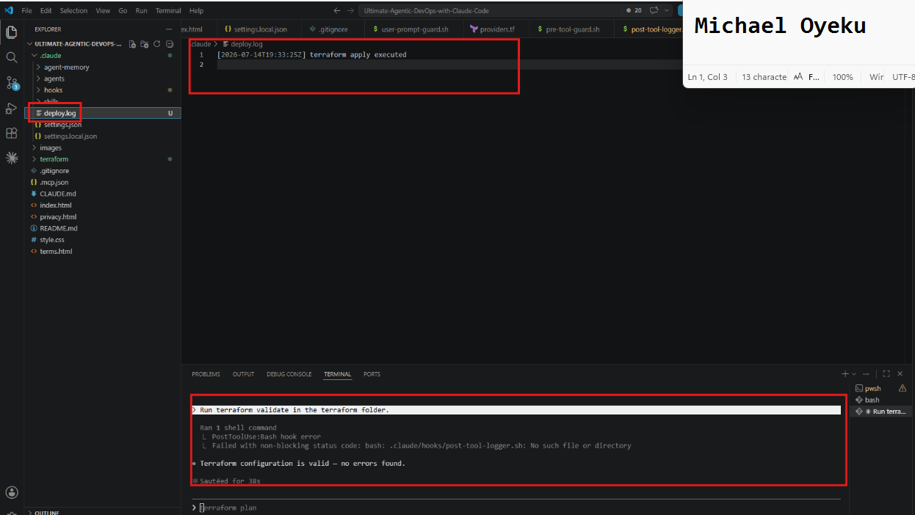

Assignment 7 — A Claude That Remembers

Task 1 — Find the Memory File Location

Screenshot 1 — Memory file path shown by Claude
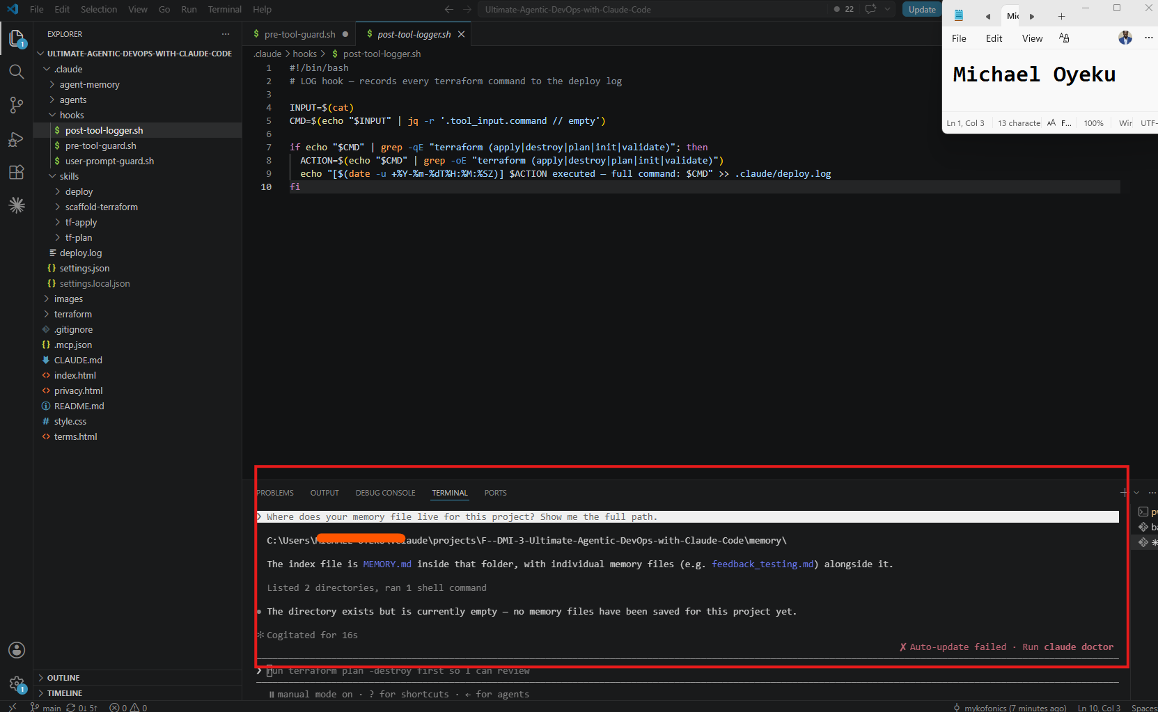

Task 2 — Give Claude Information to Remember

Screenshot 2 — Claude confirming the memory was saved
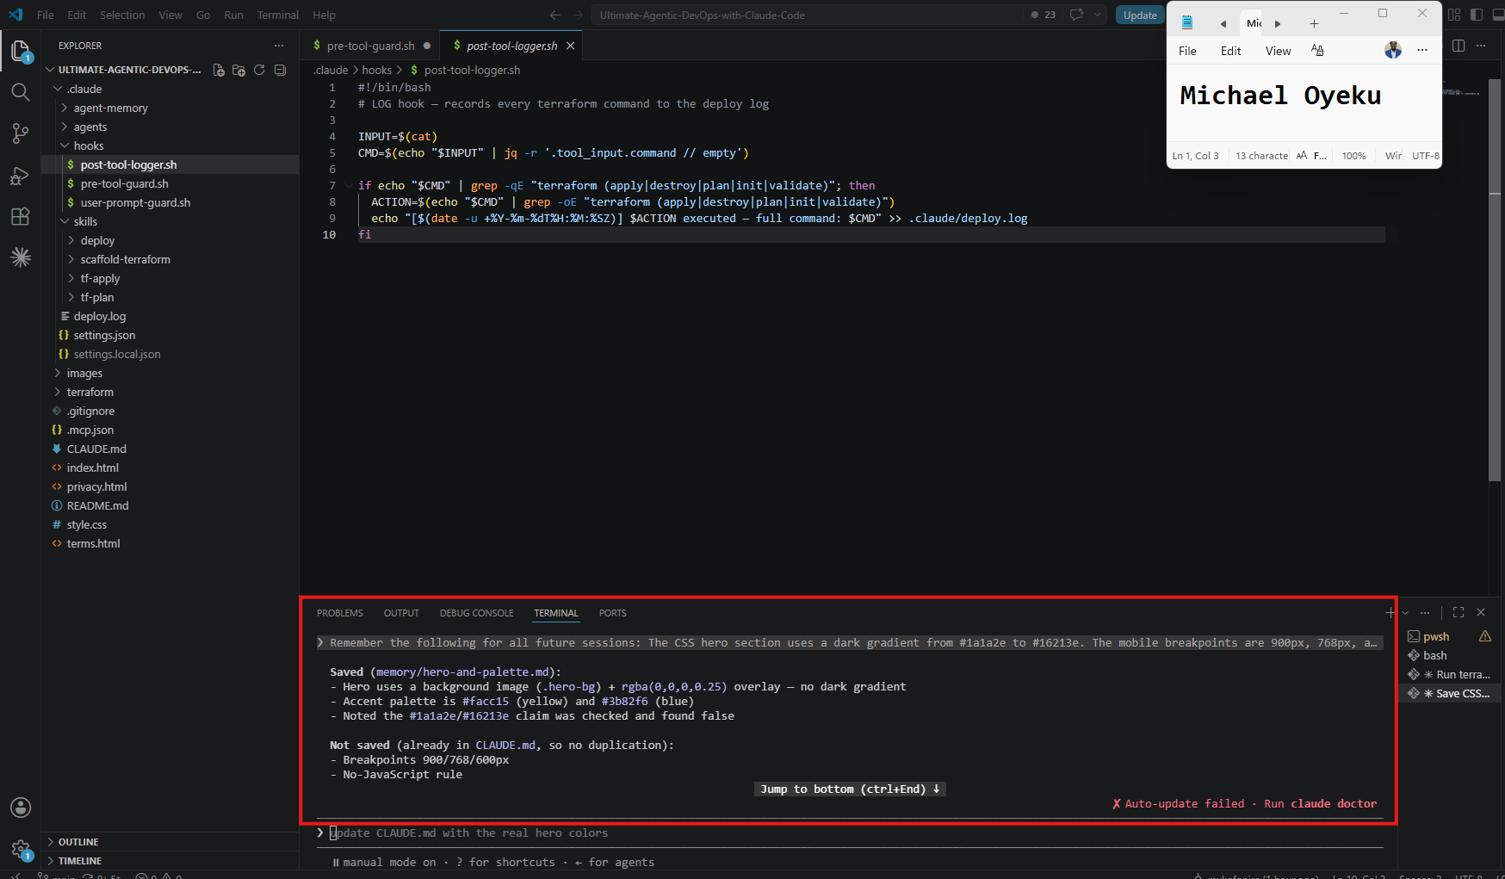

Screenshot 3 — The MEMORY.md file open in VS Code showing the saved content
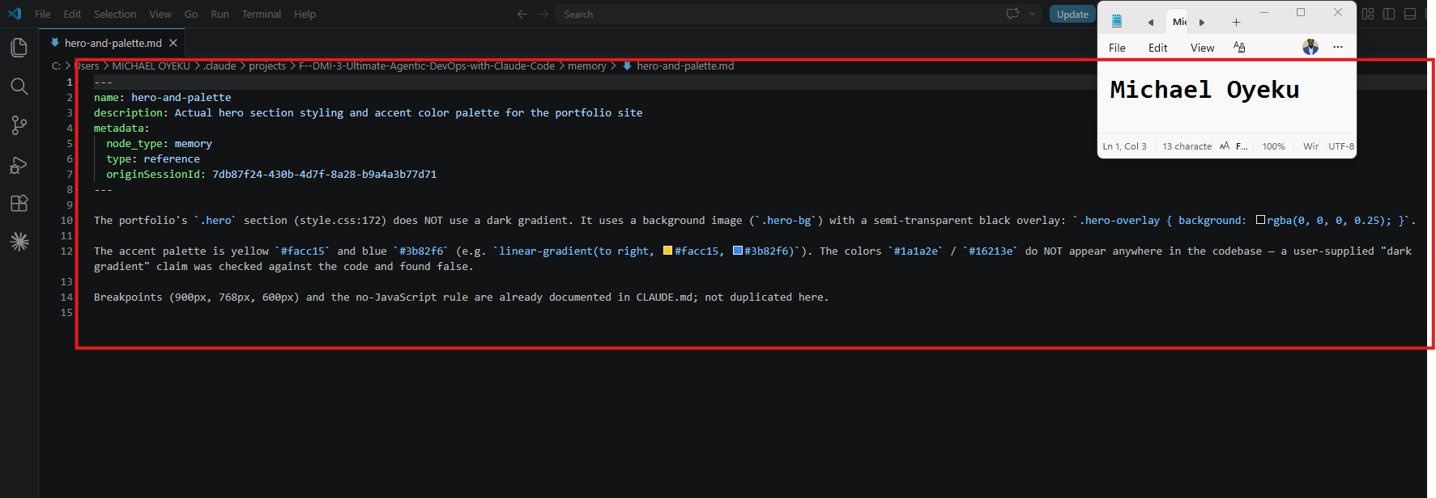

Task 3 — Close the Session Completely

Screenshot 4 — VS Code reopened with a fresh Claude Code session showing no previous conversation
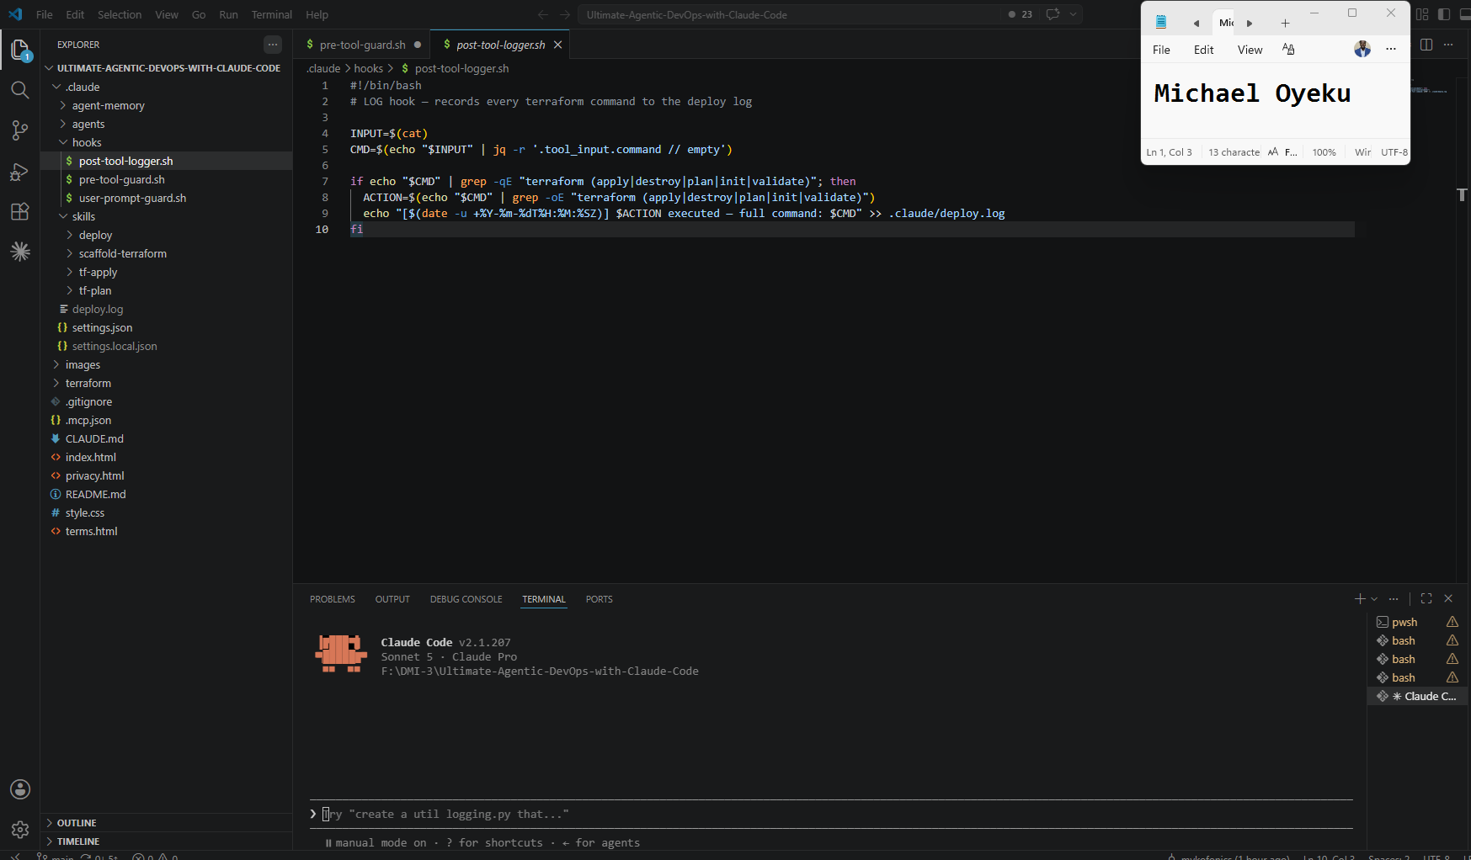

Task 4 — Prove Memory Recall Across Sessions

Screenshot 5 — Claude recalling hero section colors
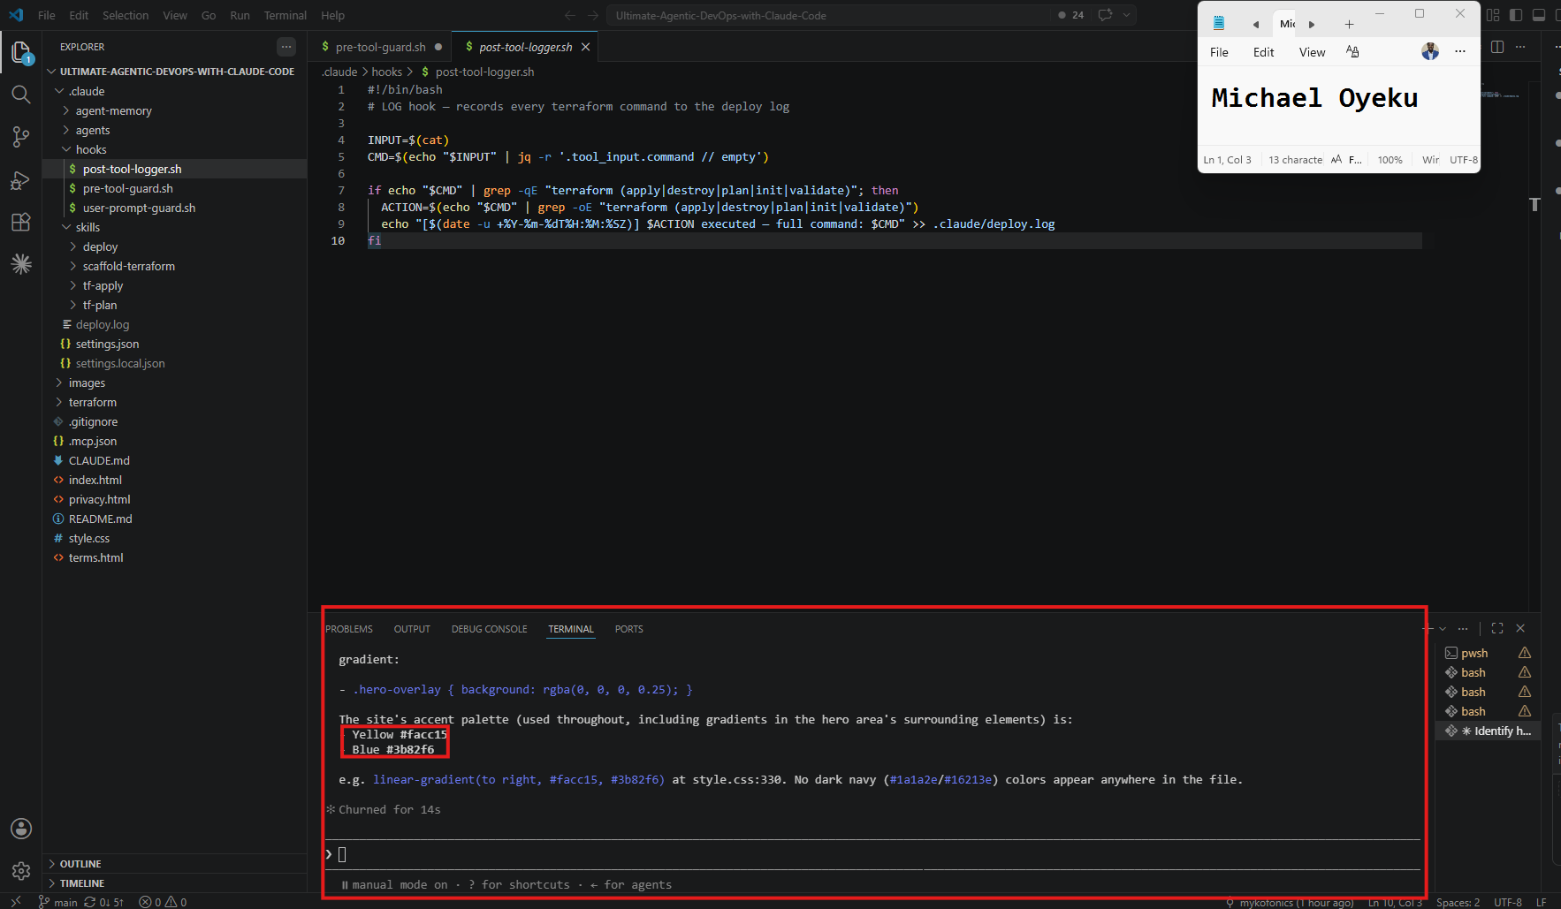

Screenshot 6 — Claude refusing JavaScript request based on memory rule
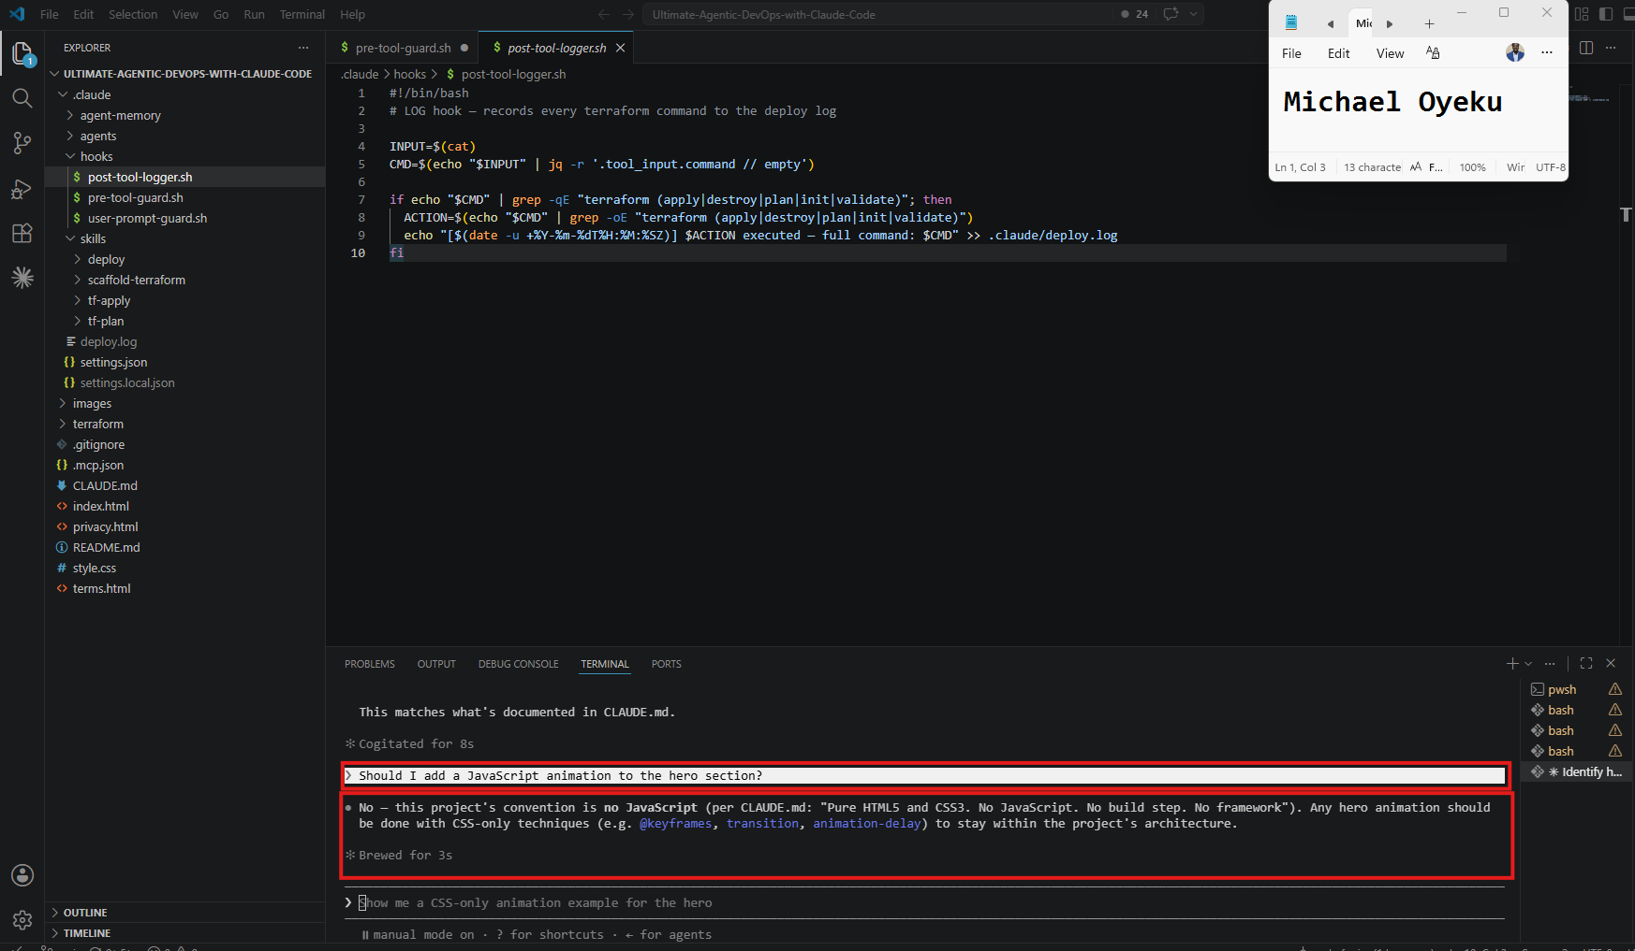

Linkedin Post Link
https://www.linkedin.com/posts/oyeku-michael-2215a920_dmibypravinmishra-agenticai-claudecode-activity-7482930954634833922-imsr?utm_source=share&utm_medium=member_desktop&rcm=ACoAAARb4_kBmnrqkDDsuuYPPXrVCKNYnevZPAo

GitHub Repository URL
Paste your forked repository URL here:
https://github.com/mykofonics/Ultimate-Agentic-DevOps-with-Claude-Code.git

Assignment 8 — Week 2 Reflection Blog
Part of the DevOps Micro Internship (DMI) Cohort 3 with Agentic AI
Task 1 — Write Your Reflection Blog

Goal
Write a reflection blog covering your Week 2 learning experience.

Evidence

Screenshot 1 — Blog published and visible
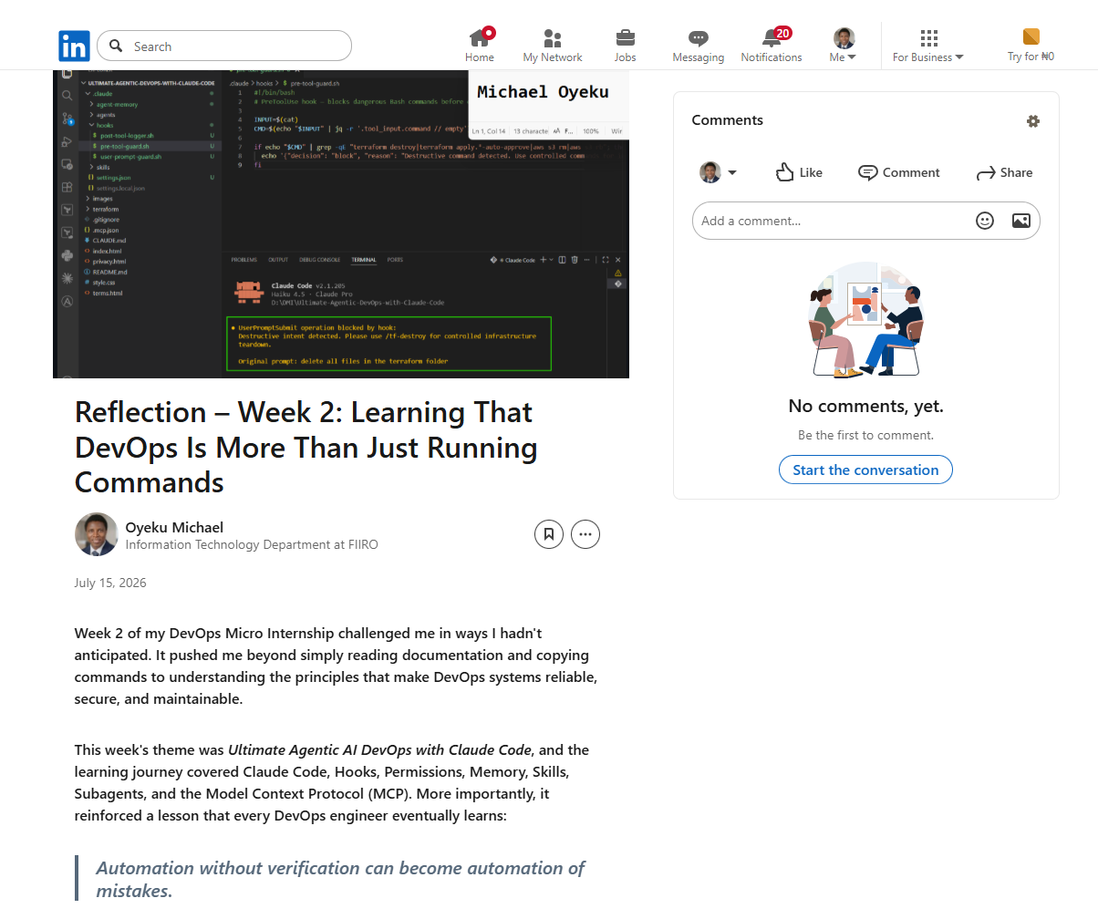

Submission Field
Blog Link:
_https://www.linkedin.com/posts/oyeku-michael-2215a920_reflection-week-2-learning-that-devops-ugcPost-7482955432416960512-9baP/?utm_source=share&utm_medium=member_desktop&rcm=ACoAAARb4_kBmnrqkDDsuuYPPXrVCKNYnevZPAo

Task 2 — Create LinkedIn Post

Screenshot 2 — LinkedIn post published
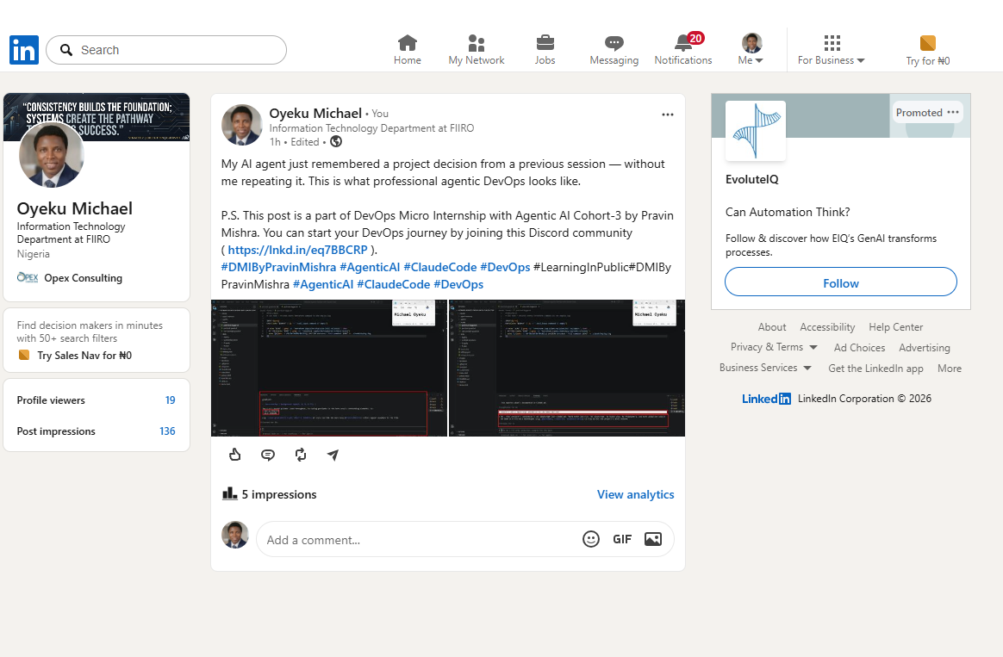
LinkedIn Post Content link

https://www.linkedin.com/posts/oyeku-michael-2215a920_dmibypravinmishra-agenticai-claudecode-ugcPost-7482930953905070081-ytuQ/?utm_source=share&utm_medium=member_desktop&rcm=ACoAAARb4_kBmnrqkDDsuuYPPXrVCKNYnevZPAoLinkedIn Post Link:

